**Supply7**

**PF**

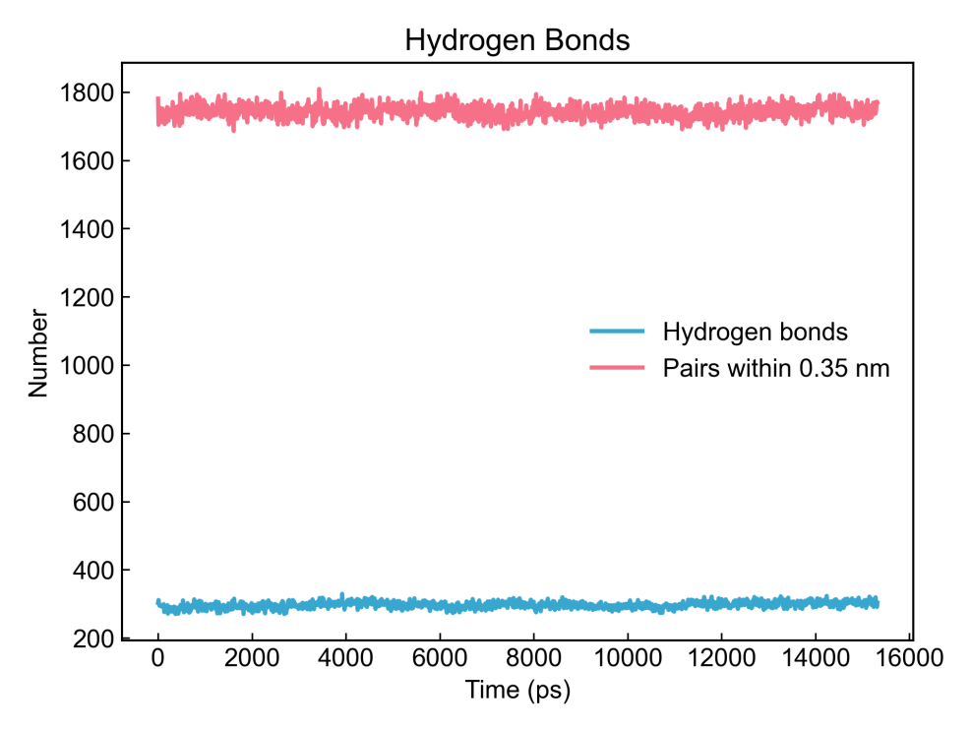

**ESP,SSP**

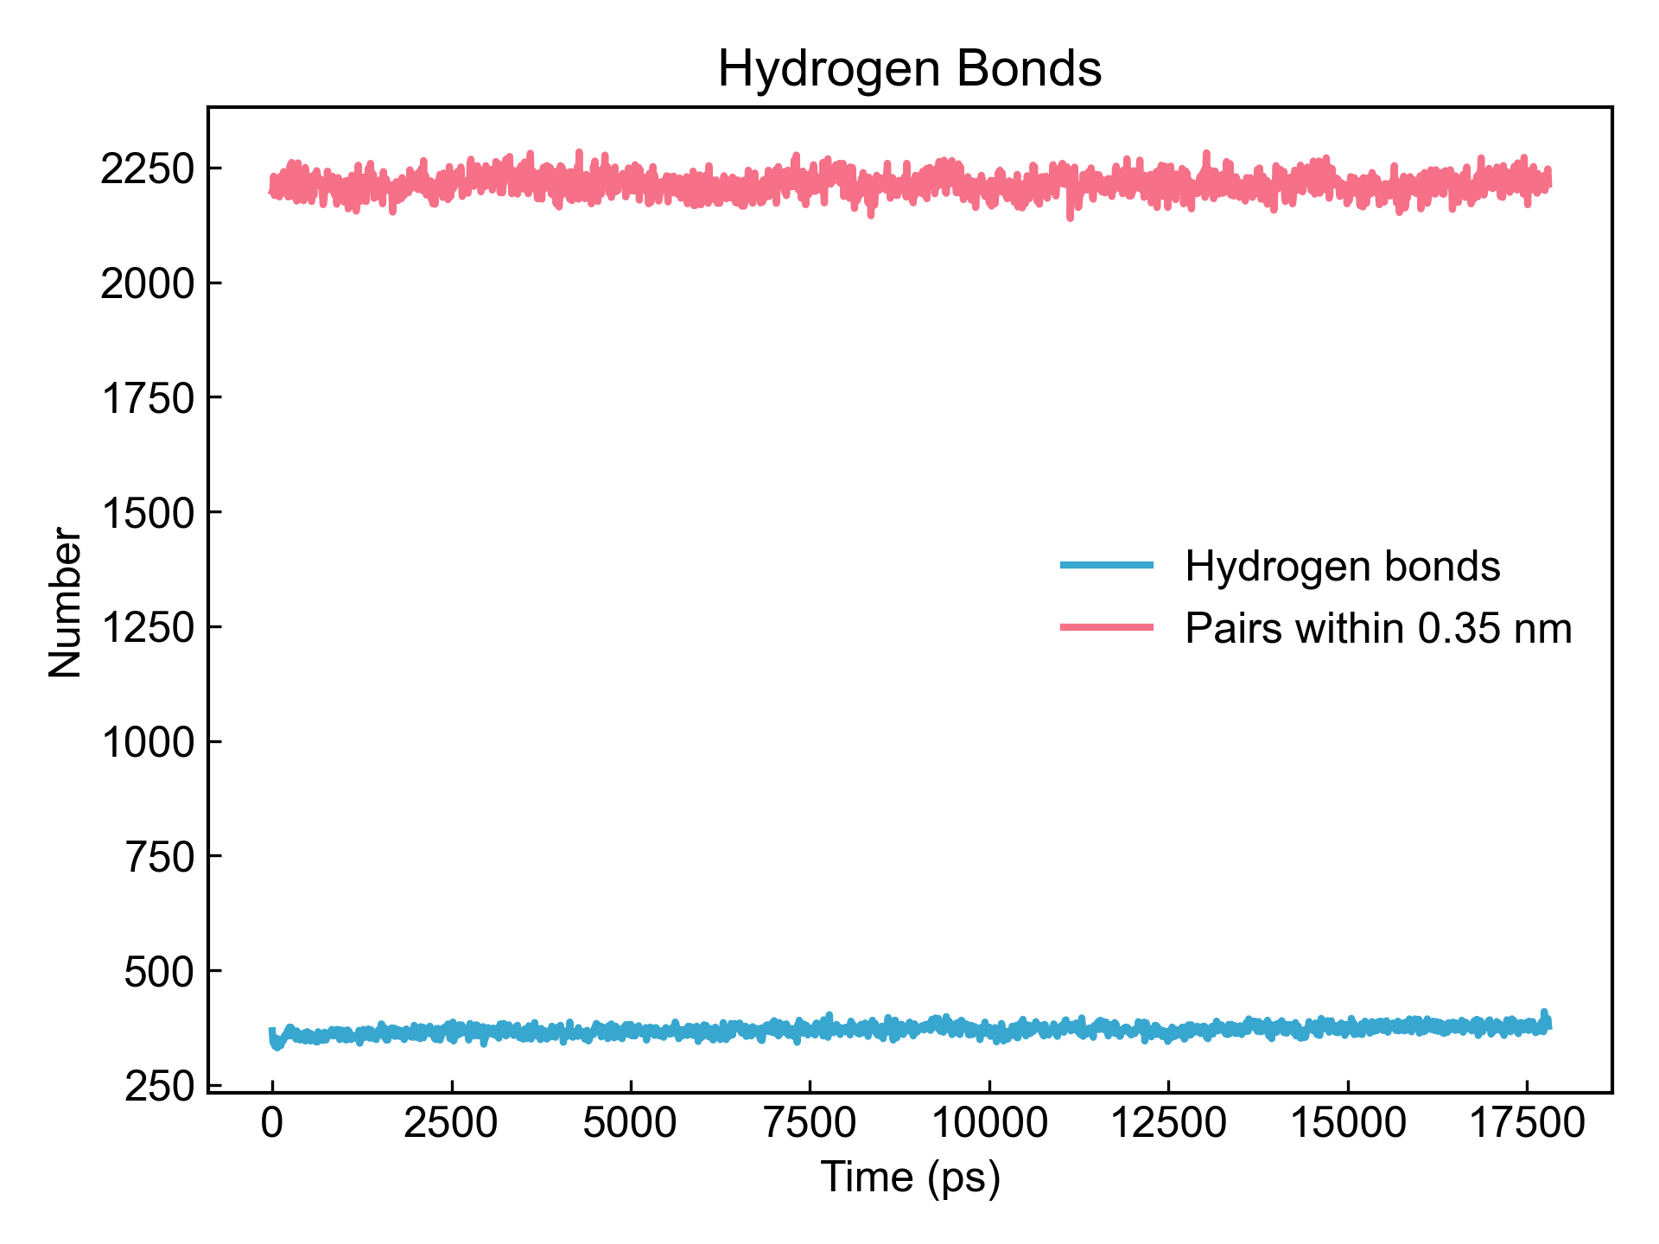

**(**https://github.com/ZhangChengCADEN/Supply/tree/main**)**